Influenza A(H1N1) aka Swine Flu

IAP ACVIP statement on ongoing outbreak of H1N1 in India

Situational analysis:

Historical perspectives

H1N1 pandemic in 2009-10: The pandemic of A (H1N1) was first reported in India in 2009. It had several characteristics that differentiated it from seasonal flu. Globally, the illness rates were highest in children and young adults (20-40% of the population), the hospitalization rates were highest in children below one year of age, and the ‘case fatality rates’ (CFR) varied tremendously and were estimated to be between 0.0004- 1.5%. The risk factors for severe disease and death were pregnancy, morbid obesity, asthma, children below 2; however 25% -30% of those who died had no underlying risk factor. During the 2009 pandemic, pregnant women were documented as an important risk group for severe disease across the globe.

According to the Government of India data, 22.8% of the samples out of the total samples from 202,790 persons who had been tested had been found positive for A (H1N1). In the majority, the illness was self-limited with recovery within a week. Among those tested 94 % cases recovered and 2,728 deaths were reported till December 2010. Maximum cases were reported during the months of August and September. Though the attack rate was highest in the age groups of 20-39 years and 10-19 years, the highest case-fatality was seen in the age group 20-39, followed by in the young children less than 5 years old. According to a study (2007-2010) conducted in and around Delhi (India), the percent positivity of Influenza A(H1N1)pdm09 influenza virus was highest in >5–18 years age groups when compared to seasonal influenza.

A (H1N1) influenza outbreaks during 2011in India: In 2011 due to large epidemic in 2009-10 with resultant immunity, the circulation of H1N1 slowed down and only 603 cases with 75 deaths were reported.

A (H1N1) influenza outbreaks during 2012-13 in India: The pandemic virus continued to circulate and caused waves of infections leading to hospitalization and complications in different parts of India despite the fact that the pandemic stage of the H1N1 virus had ended in August 2010. Once a pandemic has occurred, it is expected to have sporadic outbreaks of smaller magnitude in subsequent few years. In 2012, there were 5,044 reported cases of swine flu, which claimed the lives of 405 people. Northern India had an unusual heightened activity of A (H1N1) influenza in first quarter of 2013 that led to 261 deaths till February 28th 2013. However, in 2013, there were total 5,253 cases and 699 deaths in the entire year.

A (H1N1) influenza in 2014 in India: Last year (in 2014), the H1N1 circulation remained low and only 937 cases were reported in the country leading to 238 deaths (Table I).

Current situation

A (H1N1) influenza in 2015 in India: As per the data from Ministry of Health and Family Welfare, Government of India during the period 1 January 2015- 17 February 2015, the total number of H1N1 cases is 8423 and number of deaths is 624. Largely the cases are from Rajasthan, Gujarat, Delhi, Telangana, Maharashtra, Karnataka, Madhya Pradesh, Tamil Nadu and whereas largely the deaths due to H1N1 are in Rajasthan, Gujarat, Madhya Pradesh, and Telangana.

As far as state-wise data is concerned, till Feb 17, 2015, Rajasthan reported the highest number of cases (3302 cases with 183 deaths), followed by Gujarat (1936 cases and 155 deaths), Delhi (1679 cases and 7 deaths), Telangana (1100 cases and 51 deaths), Maharashtra (442 and 58 deaths), Madhya Pradesh (298 cases and 76 deaths), and Karnataka (281 cases and 10 deaths). So this year, the disease is following the pattern of 2009-10.

Table I. Cases and deaths caused by Influenza A H1N1 (Swine Flu) Year-wise, 2009-15.

Time period | May 2009-Dec 2009 | Jan 2010-Dec 2010 | Jan 2011-Dec 2011 | Jan 2012-Dec 2012 | Jan 2013-Dec 2013 | Jan 2014-Dec 2014 | Jan 2015-Feb 2015*
Cases | 27236 | 20604 | 603 | 5044 | 5253 | 937 | 8423
Deaths | 981 | 1763 | 75 | 405 | 699 | 238 | 624
Mortality ratio | 3.60% | 8.55% | 12.44% | 8.03% | 13.31% | 25.40% | 7.41 %
* Data till February 17, 2015

(Source: Office of the Director, Emergency Medical Relief, Directorate General of Health Services, Government of India, New Delhi.)

‘Seasonal’ versus ‘pandemic flu’

‘Seasonal flu’ usually has severe disease in children below 2 years, individuals above 65 years, and in persons with chronic medical conditions, whereas ‘pandemic flu’ more severely affects children and causes deaths in young adults having no risk factors. Sparing of elderly, very rapid transmissibility and high attack rates are other differentiating features. Overall, the severity and mortality of ‘pandemic flu’ was higher than seasonal flu (CFR of 0.89% vs 0.13%) in 2009-10.

A H1N1 usually has very rapid transmissibility and high attack rates and the severity and mortality is higher than seasonal flu. This may be due to a strain against which significant neutralizing antibodies do not exist.

Circulating strain of current A (H1N1) outbreaks in India

As per the data analyzed till September 2014, the majority of circulating isolates/strain in India was similar to the original A/California/7/2009 (H1N1)pdm09-like virus with majority falling between clades 6 & 7. However, the strains circulating since then (i.e. from September onward) shall be analyzed and reported only in the upcoming meeting of WHO on Feb 22-23 (Figures I-III). Chances are the virus has not drifted much and even the Sept 2014 recommendation was to use the same strain in vaccines used earlier, i.e. A/California/7/2009 (H1N1)pdm09-like virus. But we do not know if there has been some significant genetic mutation/drift since then. Further, the A (H1N1) predominates since week 53 of last year only. It is difficult to predict the future circulation of different types/subtypes of influenza viruses in the country. Furthermore, the yearly type/subtype distribution varies significantly from region to region, and from site to site.

Role of vaccines

Influenza vaccines

Most of the current seasonal influenza vaccines include 2 influenza A strains and 1 influenza B strain. Globally, trivalent inactivated vaccines (TIV) and live attenuated influenza vaccines (LAIV) are available. Only one brand of LAIV, Nasovac-S (Serum Institute of India) is available in India. However, It cannot be prescribed to children <2 years of age, high risk individuals and pregnant women.

Trivalent influenza vaccines are the only influenza vaccines licensed for vaccination of children <2 years of age, persons aged ≥50 years, and for pregnant women. Current trivalent influenza vaccines are not licensed for children <6 months of age.

Which vaccine to use?

All currently available trivalent vaccines now have the influenza strain that is antigenically similar to 2009 pandemic swine flu strain i.e. A(H1N1)pdm09. Hence, there is no need to go for separate ‘swine flu’ vaccine. For healthy individuals 2-49 years of age, LAIV provides broader and higher levels of protection than trivalent inactivated vaccines.

Dosage schedule

i. TIV/IIV: Trivalent/Inactivated influenza vaccine is administered intramuscularly, injected into the deltoid muscle (for vaccinees aged >1 year) or the antero-lateral aspect of the thigh (for vaccinees aged 6–12 months). Children aged 6–35 months should receive a pediatric dose (0.25 ml), and previously unvaccinated children aged <9 years should receive 2 injections administered at least 4 weeks apart. A single dose (0.5ml) of the vaccine is appropriate for school children aged ≥9 years and healthy adults.

ii. LAIV: Live attenuated vaccine is given as nasal spray, 1 dose only, but children aged 2–8 years who have not received seasonal influenza vaccine during the previous influenza season should receive 2 doses, at least 4 weeks apart. Annual vaccination (or re-vaccination, even if the vaccine strains are identical) is recommended, particularly for high-risk groups.

Are the available vaccines effective against current outbreaks of H1N1?

All the available TIVs and LAIV have 'A/California/7/2009 (H1N1)pdm09-like virus' strain which, as described above, is the main circulating strain responsible for 'swine flu' as per the data available till September 2014. Whether any significant 'drift' has occurred since then would only be known by the end of this month, i.e. February 2015. However, the chances of major 'drift' of the same are low. If we presume that the same strain is prevailing in India, the efficacy of all currently available flu vaccines against A (H1N1) would be much higher. Though there is no India specific study, all the available studies from Europe, Australia, USA, and Korea reported high effectiveness of influenza vaccines (whether trivalent or mono-valent). According to a recent systematic review & meta-analysis, vaccine effectiveness (VE) of A(H1N1)pdm09 for confirmed illness was 86% (73-93%) based on 11 case-control studies and 79% (22-94%) based on two cohort studies (Ref. Vaccine. 2012; 30:3209-22). There is one India-specific case control study performed with monovalent live attenuated influenza A(H1N1)pdm 2009 vaccine (Nasovac-TM by Serum Institute of India) in Pune during June-December 2010. It found an overall effectiveness (VE) of 75.5% (Ref. Hum Vaccin Immunother. 2014;10:566-71). So, the available flu vaccines should have reasonable protection against ongoing outbreaks of 'swine flu' aka A(H1N1).

However, this is not true for other two strains. The A (H3N2) had drifted significantly and there is lot of variation in the B strain contained in the available vaccine and circulating strain. Hence, current vaccines will not be much effective against A-H3N2 and B strains.

Onset of action and duration of protection

Following vaccination, anti-HA antibody titers peak 2- 4 weeks post-vaccination in primed individuals but may peak 4 weeks or later in unprimed individuals or older adults. Serum antibody titers may fall by 50% or more by 6 months after vaccination, with the degree of reduction being proportional to the peak titers achieved. Vaccine-induced serum antibody titers then remain stable for 2 to 3 years. Evidence from clinical trials suggests that protection against viruses that are similar antigenically to those contained in the vaccine extends for at least 6–8 months.

It is difficult to predict the pattern of viral circulation in coming months. We cannot predict how long the ongoing current outbreak would last. So, it is worthwhile to offer vaccine to certain high-risk individuals and healthcare professionals.

Shall one wait for new flu vaccine arrival in the market?

The 'new' influenza vaccine for 'southern hemisphere' shall be available by June/July 2015 with new strains (A (H3N2) & B), but the A(H1N1) strain will remain the same. If any change in the circulating strain of A(H1N1) is noticed, it will only be incorporated in the formulations designed for 2015 'northern hemispheric' product that would come in the market by the end of this year. So if our focus is H1N1, it is advisable to offer the currently available vaccine to targeted groups of individuals.

IAP ACVIP recommendations:

Considering the fact that the available influenza vaccines are going to have much better effectiveness against the circulating A(H1N1)pdm09 strain than other influenza viruses owing to more ‘complete match’ between the strain circulating in the community and the strain contained in the vaccines, IAP ACVIP reiterates its earlier recommendation of using the influenza vaccine in all children with risk factors and also wherein the vaccine is desired/requested by the parents. Even pediatricians examining suspected cases of A (H1N1) are advised for vaccination against A (H1N1) influenza.

So, the following groups of individuals should be offered influenza vaccine:

1-Children with risk factors*;
2-Health care professional including pediatricians;
3-Laboratory personnel and healthcare workers;
4-On demand of anxious parents after one-to-one discussion.

*The ‘high-risk children’ category includes the following:
•Chronic cardiac, pulmonary (excluding asthma), hematologic, renal (including nephrotic syndrome), chronic liver diseases and diabetes mellitus
•Congenital or acquired immunodeficiency (including HIV infection),
•Children on long term salicylates therapy,

In the end, IAP advises its membership that there is no need to get unduly worried about the recent spurts in the activity of influenza A (H1N1) virus in the country. Though it is expected to have A (H1N1) infections which are slightly more severe with higher mortality than seasonal influenza caused by other co-circulating strains, the majority of cases are mild and self-limiting.

Sources:

1-Ministry of Health & Family Welfare, Government of India. Influenza, A H1N1.
2- Global Influenza Surveillance and Response System (GISRS).
3- Vaccines against influenza. WHO position paper-November 2012. Wkly Epidemiol Rec 2012; 87: 461–476.
4- Influenza Vaccination in India: Position Paper of Indian Academy of Pediatrics, 2013. Indian Pediatr 2013; 50: 867-74.
5- Yin JK, et al. Impacts on influenza A(H1N1)pdm09 infection from cross-protection of seasonal trivalent influenza vaccines and A(H1N1)pdm09 vaccines: systematic review and meta-analyses. Vaccine. 2012; 30:3209-22.
6- Kulkarni PS, et al. Effectiveness of an Indian-made attenuated influenza A(H1N1)pdm 2009 vaccine: a case control study. Hum Vaccin Immunother. 2014;10:566-71.

Fig I. Influenza surveillance, India 2009-12.
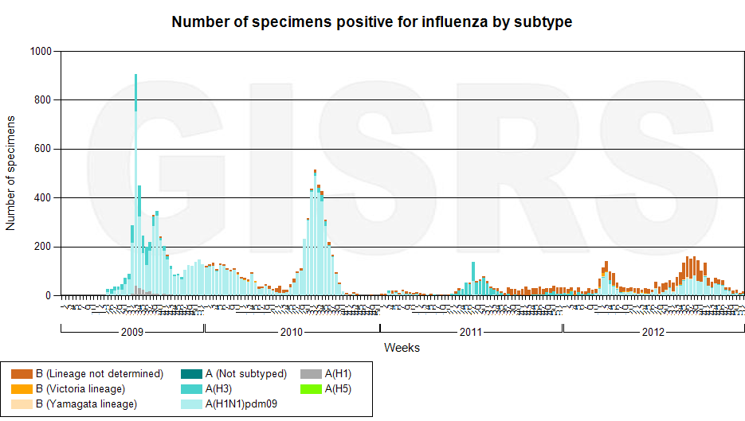

Fig. II. Influenza surveillance, India 2013-15 (till week 4).
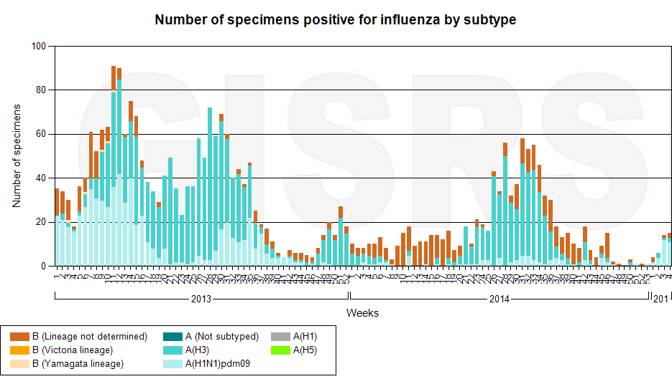

Fig. III. Influenza surveillance, India last 12 months (from week 8, 2014 to week 5, 2015).
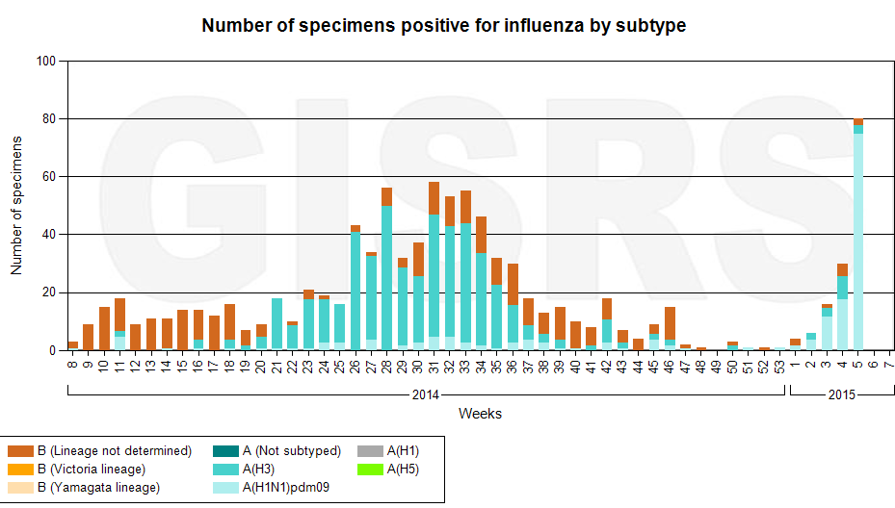

(Source: Influenza Laboratory Surveillance Information generated on 09/02/2015 05:06:18 UTC by the Global Influenza Surveillance and Response System (GISRS), India.)

